
SRM Institute of Science and Technology
Mode of Exam
OFFLINE
College of Engineering and Technology
School of Computing
DEPARTMENT OF COMPUTING TECHNOLOGIES
SRM Nagar, Kattankulathur – 603203, Chengalpattu District, Tamilnadu
Academic Year: 2021-2022 (EVEN)
Test: CLAT-1 Date: 4-4-2022
Course Code & Title: 18CSC205J: Operating systems Duration: 1 Period
Year & Sem: II & IV Max. Marks: 25 Marks

Course Outcomes (CO): |  |  |  |  |  |  | At the end of this course, learners will be able to:
CO-1 : |  | Express the fundamental concepts in operating system
Program Outcomes (PO)
1 | 2 |  | 3 | 4 | 5 | 6 |  | 7 | 8 | 9 | 10 | 11 | 12 | PSO
Engineering Knowledge | Problem Analysis |  | Design & Development | Analysis, Design, Research | Modern Tool Usage | Society & Culture |  | Environment & Sustainability | Ethics | Individual & Team Work | Communication | Project Mgt. & Finance | Life Long Learning | PSO - 1 | PSO - 2 | PSO – 3
3 |  |  | 3 |  |  |  |  |  |  |  |  |  |  | 2

Part - A
(5 x 1 = 5 Marks)
Instructions: Answer all
Q. No | Question | Marks | BL | CO | PO | PI Code
1 | Time Sharing technique handles  - Single Interactive Job  - Multiple Iterative Job  - Recent Interactive Job  - Old Interactive Job | 1 | 1 | 1 | 1 | 1.6.1
2 | Interrupts make an Operating System more  - Rigid  - Expensive  - Reliable  - Flexible | 1 | 1 | 1 | 1 | 1.6.1
3 | Work can be ________ while using multiprogramming batch processing.  - Rigid  - Expensive  - Reliable  - Flexible | 1 | 1 | 1 | 1 | 1.6.1
4 | When you start up the computer the boot up storage at which the BIOS versions manufacturer and data are displayed on the monitor is called  A. Bootstrap  B. Power on self-test (POST)  C. System configuration  D. Kernel loading | 1 | 1 | 1 | 1 | 1.6.1
5 | What is dispatch latency?  A. The time taken by the dispatcher to stop one process and start another  B. The time taken by the processor to write a file into disk  C. The whole time taken by all processor  D. None of Above | 1 | 1 | 1 | 1 | 1.6.1
Part – B
(5 x 4 = 20 Marks)
Instructions: Answer any 5
6 | Compare the Modes of operation in operating system. | 4 | 4 | 1 | 2 | 2.6.4
7 | Write short notes on Multiprogramming | 4 | 3 | 1 | 1 | 1.7.1
8 | Relate Process Control Block with respect to process. | 4 | 3 | 1 | 2 | 2.6.2
9 | With a neat sketch interpret addition of medium-term scheduling | 4 | 3 | 1 | 3 | 2.6.2
10 | Illustrate inter-process communication | 4 | 2 | 1 | 1 | 1.7.1
11 | With a suitable example to illustrate IPC POSIX Producer | 4 | 2 | 1 | 2 | 1.7.1

Course Outcome (CO) and Bloom’s level (BL) Coverage in Questions

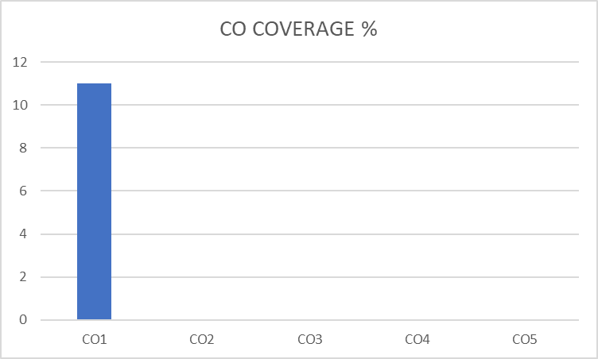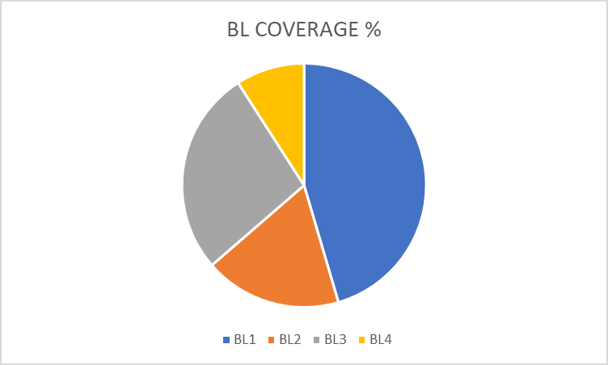

Approved by the Audit Professor/Course Coordinator

